**DAILY ONLINE ACTIVITIES SUMMARY**

|  |  |  |  |  |  |  |  |  |
| --- | --- | --- | --- | --- | --- | --- | --- | --- |
| **Date:** | **04/06/2020** | | | | | **Name:** | **Katira Krishna J** | |
| **Sem & Sec** | **8th A** | | | | | **USN:** | **4AL16CS045** | |
| **Online Test Summary** | | | | | | | | |
| **Subject** | | **SMS** | | | | | | |
| **Max. Marks** | | **60** | | **Score** | | | **45** | |
| **Certification Course Summary** | | | | | | | | |
| **Course** | **Build Swift Mobile Apps with Watson AI Services** | | | | | | | |
| **Certificate Provider** | | | **Cognitiveclass.ai** | | **Duration** | | | **2.5 Hours** |
| **Coding Challenges** | | | | | | | | |
| **Problem Statement: Python program to test Collatz conjecture for a given number.** | | | | | | | | |
| **Status: Completed** | | | | | | | | |
| **Uploaded the report in Github** | | | | | **yes** | | | |
| **If yes Repository name** | | | | | **Krishna_Katira** | | | |
| **Uploaded the report in slack** | | | | | **yes** | | | |

Online Test Details:

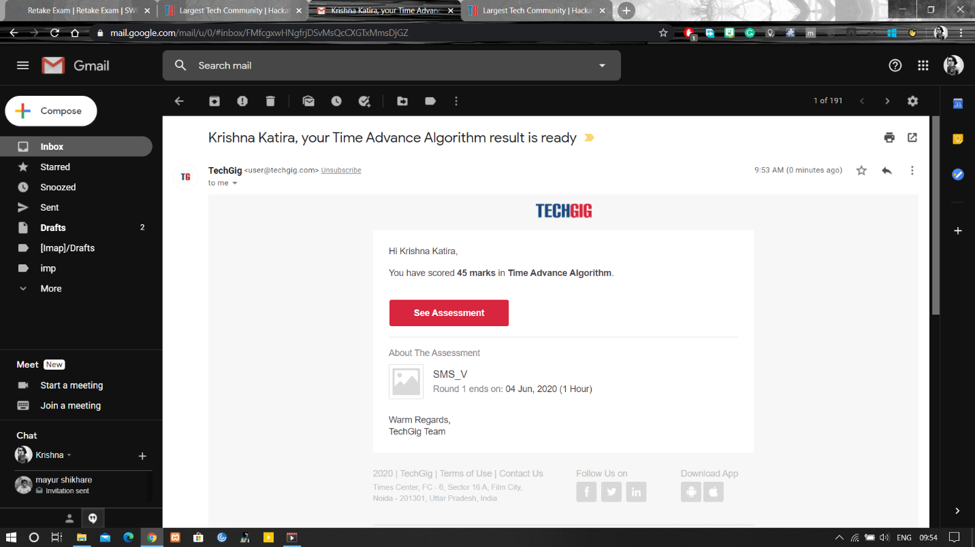

Certification Course Details:

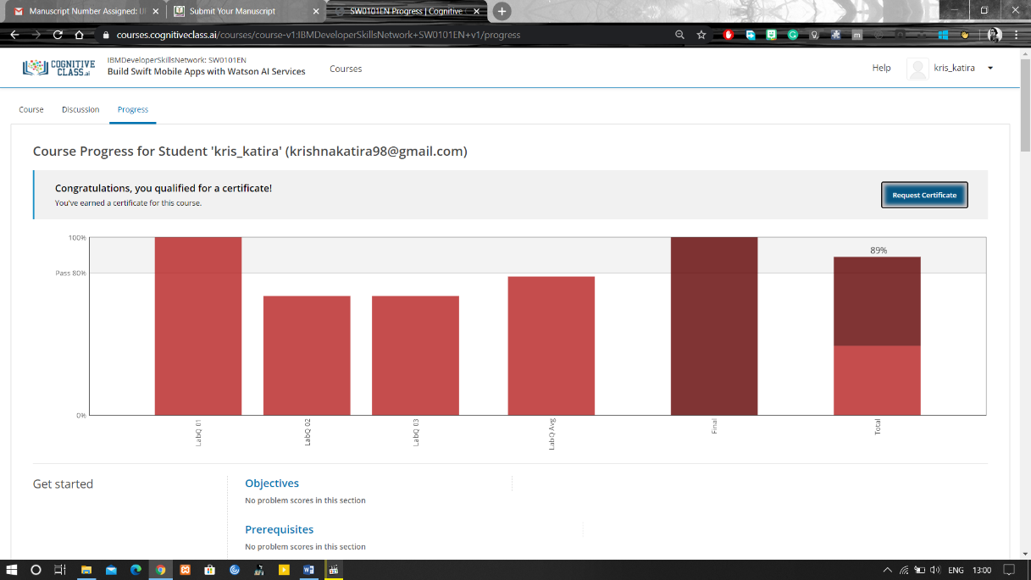

Coding Challenges Details:

**program1**

def collatz(n):

while n > 1:

print(n, end=' ')

if (n % 2):

# n is odd

n = 3*n + 1

else:

# n is even

n = n//2

print(1, end='')

n = int(input('Enter n: '))

print('Sequence: ', end='')

collatz(n)